Agricultural Awareness
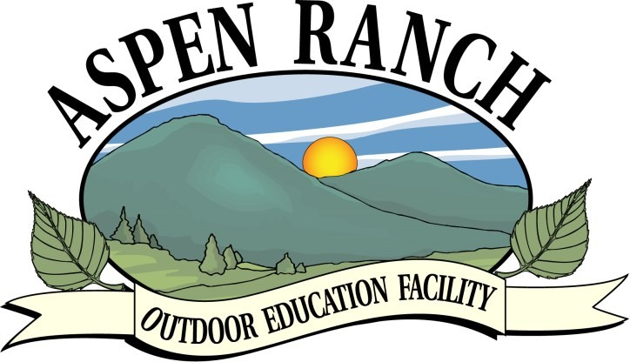

and Farm Safety

Mission: Aspen Ranch Outdoor Education Center through community support, involvement, and resources provides elementary students in Central Alberta with hands on education in agricultural awareness and farm safety.
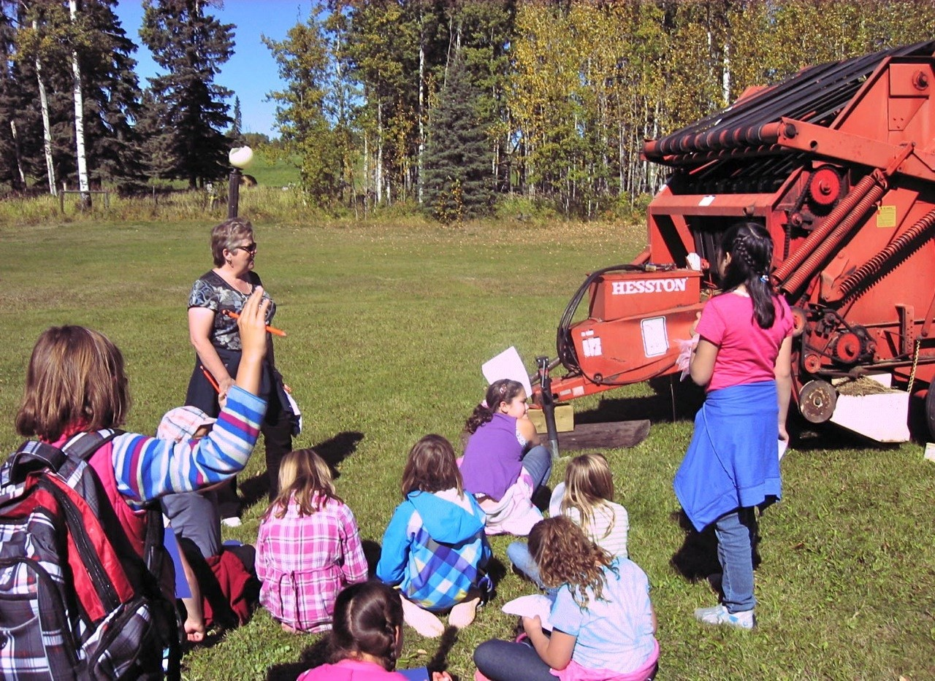

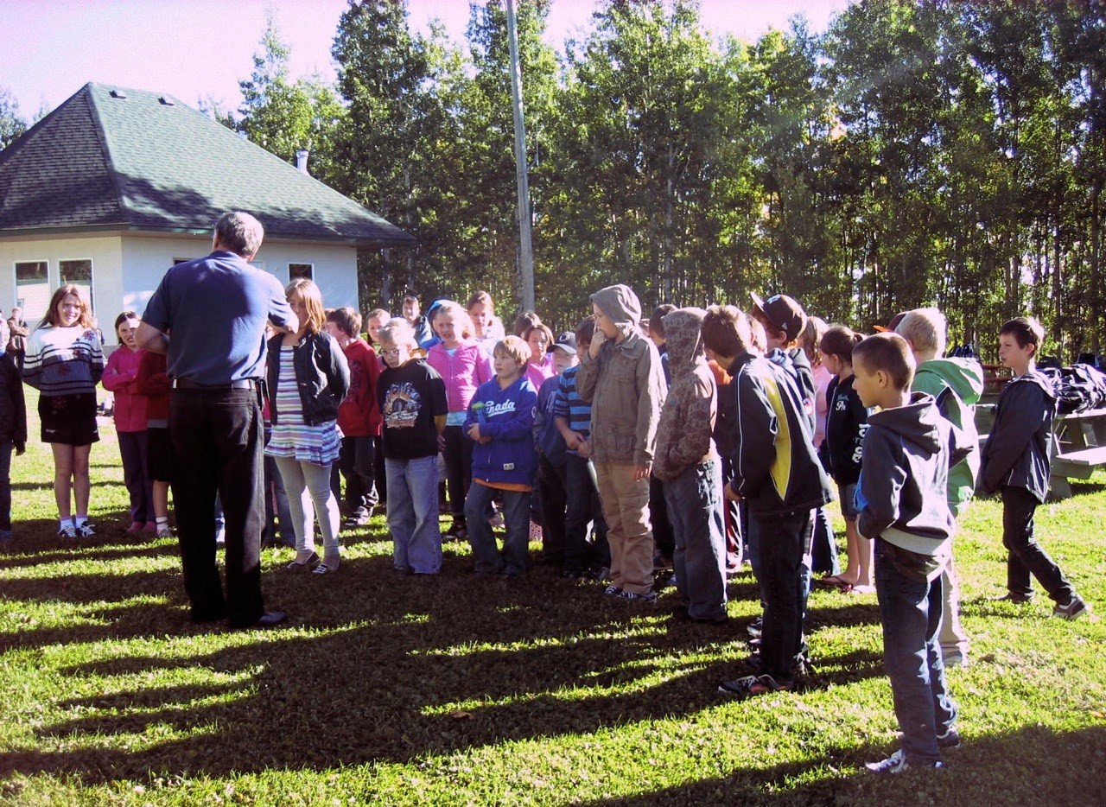

Vision: Aspen Ranch Outdoor Education Center will continue to provide hands on agricultural awareness and farm safety to elementary students through the leadership of community facilitators.

Program Highlights:
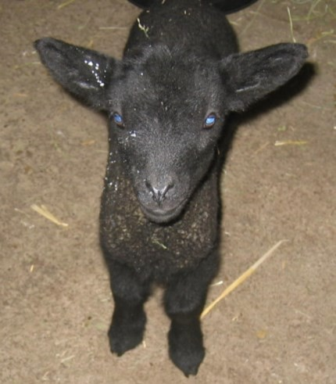

- Structured in an Outdoor Setting

- Interactive Stations with Animals and Equipment

- Farm Hazard Hunt

- Sustainable Agriculture Focus
Annual Program Details:

- Held in September each year

- Educational Field Trip Offered to Elementary Students, Free Busing for Schools

- Geared for the Grade 4 Alberta Education Program for Social Studies and Health Curriculums

- Take-home Resource Package for Teachers

Participants say:

“The program is a very good one for kids this age; to have to think about safety on the farm, acreages, at home, or in town.”

“Program will be very useful and hopefully prevent accidents and save lives.”

“Good, education like this is invaluable! Children everywhere should have an opportunity to see where their food comes from. “

“Topics of farm safety are always essential. “

“Aspen Ranch is a very educational and memorable place!”

“The ranch was very well kept and organized. It’s definitely recommended for future classes, families and friends.”

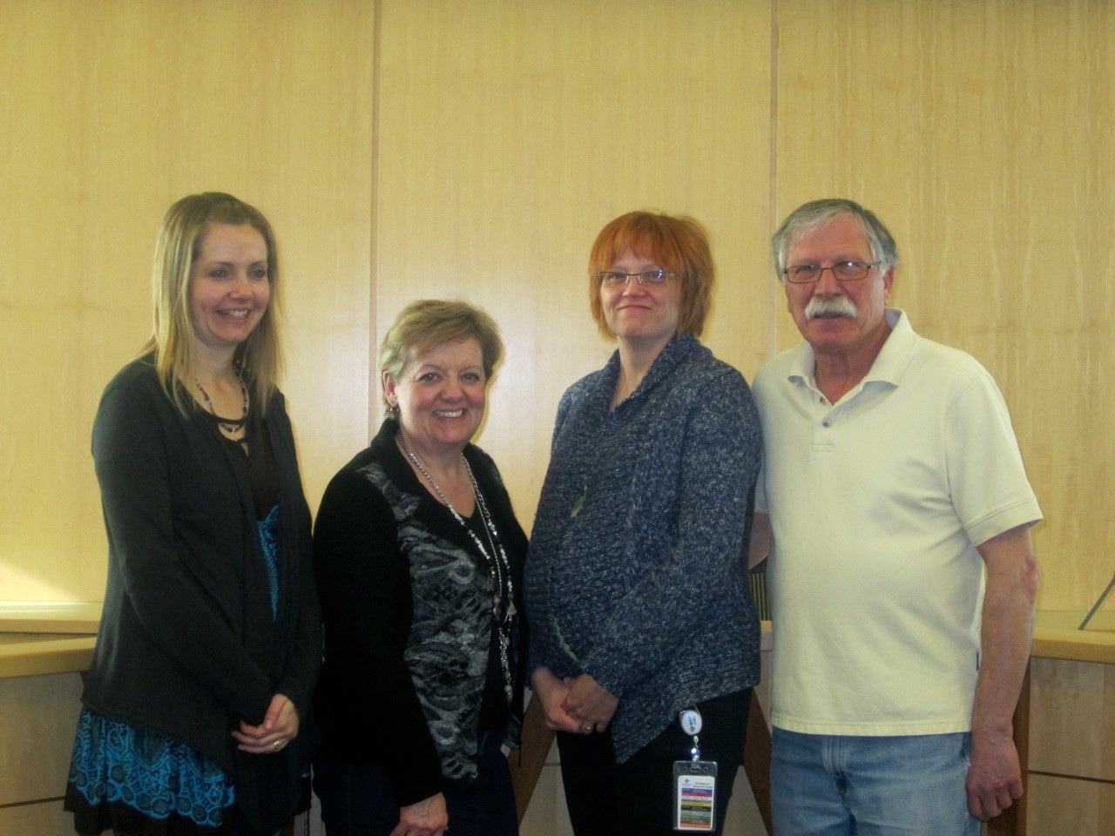
Here are some of our volunteers
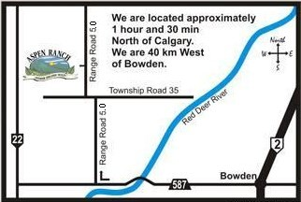

For more information on the Agricultural Awareness and Farm Safety Program please contact:

Dante 403-722-4041

Aspen Ranch

Rural Address : 350070 Range Road 5.0 Email: info@aspenranchcanada.com Website: www.aspenranchcanada.com

Please contact us if you would like to be a part of this important initiative.

Thank you to our sponsors and volunteers;

our program is fully supported by their generous donations of time and money.
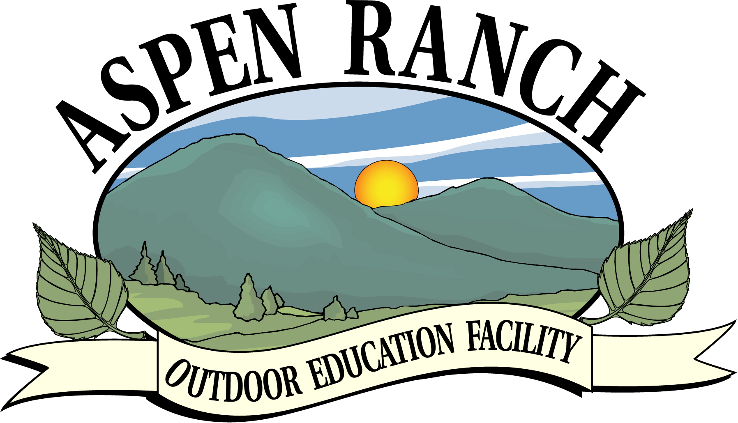

Dear Grade 4 Teacher,
Thank-you for signing up for the grade 4 “Farm Safety and Agriculture” field trip with us. The date that has been scheduled for your group to attend this program has been sent to you either by fax or email.

The following items have been enclosed in this Teachers Guide package:
-Day Program
-Student Activity Hand Out (Students and Adults will receive a hard copy of this when they arrive)
-Supervisor’s Info
-Transportation Billing
-Program Evaluation
-4H Presentation Template

-A map of how to get to our location if found on our web site at www.aspenranchcanada.com (contact info section)
-Contributors

Pease note that this activity is held out of doors and students should dress for this!

If you have any questions feel free to contact our Dante, our Education Director, at 403-722-4041

Grade 4 Farm Safety and Agriculture Awareness Program at Aspen Ranch

10:00 am Welcome and Orientation – Large Group (All Classes) at picnic area

Farm Safety Presentation – Group No. 1 divided into smaller groups go to Main Farm Yard with Adult Leader

Agriculture Awareness Presentation – Group No. 2 divided into smaller groups go to Ag. Area with 4H Leader

Environmental Stewardship Presentation –Group No. 3 meet in Hall

Groups Rotate

12:00 noon Lunch – Picnic Area/UFA Pavilion

12:30 pm

Groups Rotate

1:45 pm Thank-yous - Large Group Meeting at picnic area

2:00 pm Leave to Return to School - Goodie Bag – On Bus

- Prior to coming to the ranch please ensure that all students and adults dress for the weather, rain or shine we will go on with our programs (within reason of course; we will notify you if we have to reschedule because of weather)

-Prior to your group arriving at the ranch, please divide your students into small groups so that there is a ratio of one adult per twelve students.

Thanks.

Camps for Children Education Association
Teacher/Supervisor Information & Evaluation Package

We ask that you do the following when visiting with us:
-Stay with your assigned group and keep in sight of supervisors at all times.
-If you get injured please let an adult know right away.
-If you get cold let your guide know immediately.
-Dress warmly and layer your clothing.
-Wear a hat, use sunscreen, and put on bug spray.
-Have enough food and juice/water for that important energy boost.
-Enjoy the wildlife from a distance NEVER remove natural items from the area. Vegetation, insects, mammals, birds, and amphibian life is to be respected and left in the natural habitat. Do Not feed any animals or pick wildflowers.
-Please take all of your garbage out with you. Do not leave it on the trail.
-Unsafe behavior such as tripping, wrestling, and teasing is unacceptable and may result in withdrawal from the activity.
-Pets ( such as dogs, etc. ) are not permitted on the field trip.

Transportation

Please invoice your bussing costs to:

Aspen Ranch Outdoor Education Facility
Box 4, Site 25. R R 1
Sundre Alberta

T0M 1X0

Program Evaluation

- Have you enjoyed your visit and Farm Safety/Alberta Ag Awareness Program at Aspen Ranch?
__________________________________________________________________________________________________________________________________________

- What part(s) of the program did you find most beneficial to your group?
_______________________________________________________________________________________________________________________________________________________________________________________________________________

- Do you have any suggestions for program improvements?
_______________________________________________________________________________________________________________________________________________________________________________________________________________

- Would you recommend this program to other schools /groups? Why?
_______________________________________________________________________________________________________________________________________________________________________________________________________________

- Would you like to help organize and assist in next year’s program?
Name_________________________ Telephone No. ____________________

Map and Address

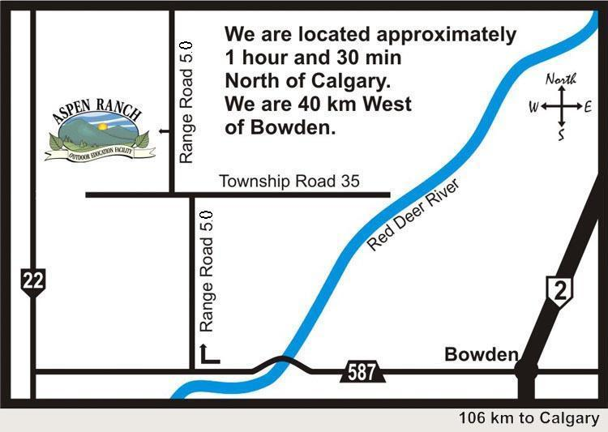

https://www.google.com/maps/d/viewer?mid=1HE2zrcmHqUWFf23-m4TEQWfSxE4&ll=51.97327384927226%2C-114.57049907679902&z=15

Please use the above link for a direct Google map showing our location

350070 Range Road 5.0

Telephone: 403-722-4041
4H Student Presentation Template (approx. 3 min)

(Agriculture industry* displays are: beef cattle, dairy cattle, honey bees, chicken, sheep, horses, and a varity of grains and feed grasses for animals that grow in Alberta’s climate)

Hi my name is___________________________________.

Today I will be talking to you about the _____________________agriculture industry*.

This industry is important because:

1.______________________________________________________________________2.______________________________________________________________________

The products produced by ____________ are:

1.______________________________________________________________________2.______________________________________________________________________3.______________________________________________________________________4.______________________________________________________________________

We care for these animals by:
1.______________________________________________________________________2.______________________________________________________________________3.______________________________________________________________________4.______________________________________________________________________

They are kept healthy by:
1.______________________________________________________________________2.______________________________________________________________________3.______________________________________________________________________

Any questions?

Thank-you for your attention and now we will move to the _______________display.

